Open up BarTender on the user's computer then select “Open an Existing BarTender Document…”

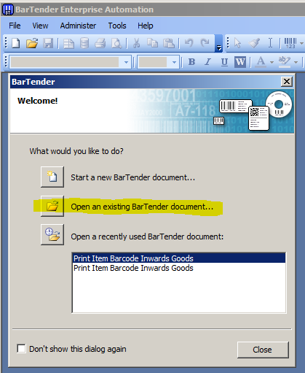

If BarTender is already open or the above screen doesn’t load, click “File” then “Open”

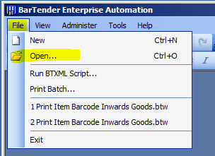

You should already be looking in the correct directory, if not, browse to \\gghgen01\gghpublic\Group Share\Released Product Barcode Register\WCHCB02

and open either “Inwards Goods WCHCB02.btw” or “Print Quick Replacement Item Barcode Label WCHCB02.btw”. These are the templates that should be being used, if they were using one of these templates and there were issues, open up the template as advised above.

Click on the print icon at the top of the page, make sure \\printers\WCHCB02 is the printer that is selected then click on “Document Properties…”.

Depending on which template is required, there will be a few differences in the settings.

For “Inwards Goods” under the “Options” tab, the **Darkness** should be set to **20**, **Width** to **65**, **Heigh**t to **20.** 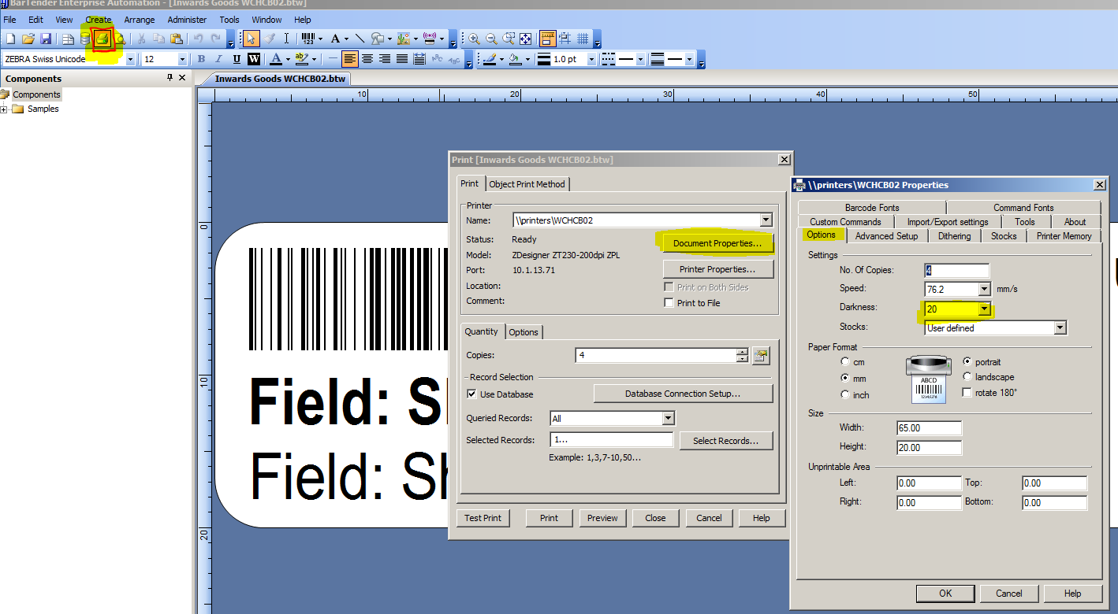

For “Print Quick Replacement Item Barcode Label” under the “Options” tab, **Darkness** should be set to **10**, **Width** to **64.90** and **Height** to **19.90**. 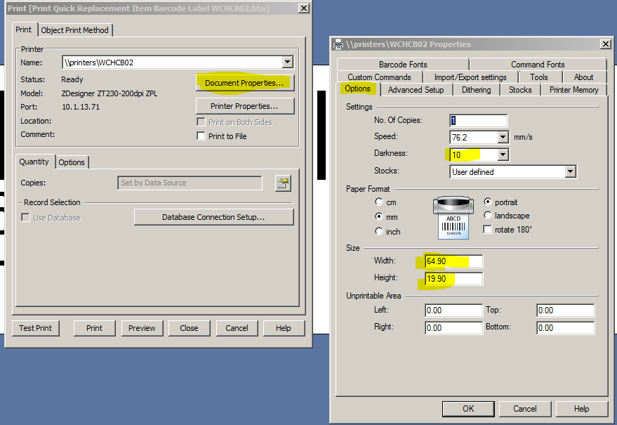

There are common settings for both templates that need to be set also. Under the “Advanced Setup” tab, the following options should be selected:

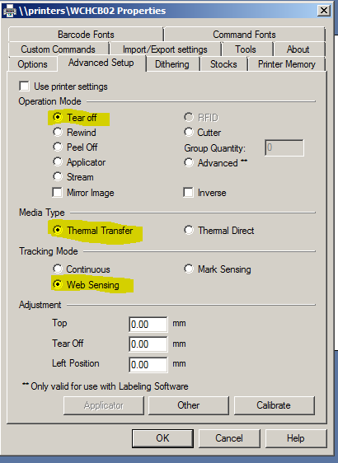

To make sure these settings change when you close out of the dialogue boxes, click “OK” and then “Close”. Then in “File” click “Save”

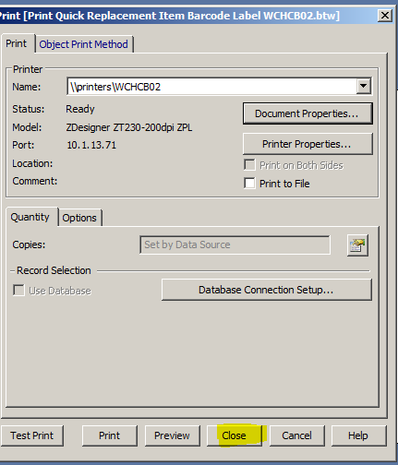

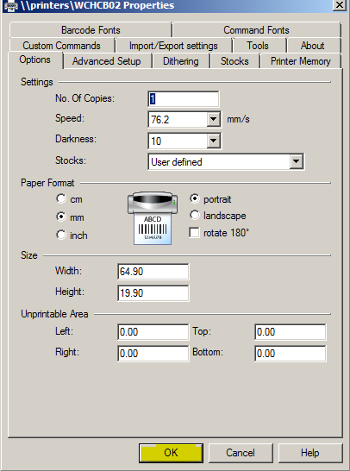

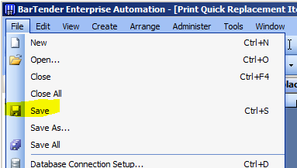

Get the user to try and print a few test labels, if there are still issues, god be with you.